Case Study- Blue apron influencer marketing

# Marketing analytics renu deepya iska|01/27/2024

Question 1 Using just the data available on the Excel “Influencers” worksheet, identify and articulate the characteristics of effective influencers for Blue Apron. Based on your analysis and insights, recommend to Blue Apron a set of influencers with whom it should build a collaborative relationship. (There is no need to provide a complete list – it is sufficient to indicate a few examples of influencers who have the characteristics you have identified). When collaborating with influencers, it is important to select influencers who are likely to share the company’s values and expectations. Several tools within Microsoft Excel could be used to address this issue, including Sorting/Filtering, PivotTable, and Regression Analysis.

Answer:

After analyzing the data from in influencers table, for a collaborative relationship it would be optimal to consider influencers with better overall engagement rates, as measured by indicators such as likes and comments. Increased engagement indicates a more active and involved audience.

Following Count: While a large following base can suggest broad reach, micro-influencers with smaller, more engaged audiences may also be beneficial. Assessing influencers with various follower counts in terms of target audience is crucial.

Post Frequency: Looking for influencers who post on a consistent basis, demonstrating ongoing involvement with their audience would peak the marketing for company.

Type of Influencer: Working with influencers whose material is consistent with Blue Apron's brand values. Considering influencers who specialize in food, cooking, or healthy lifestyle issues are appropriate.

Sponsored Influencer expertise: Prioritizing influencers that have previously been sponsored, as they may have greater expertise pushing products and collaborating with brands.

Based on these factors, here are some recommendations.:

Influencer 52: @ linamarie42403.

Characteristics: A highly engaged fitness coach.

Recommendation: Effective in marketing Blue Apron meal kits as part of a healthy lifestyle.

Influencer #89: @ the_hunger_diaries

Characteristics: Fashion fitness and nutrition expert with sponsored influencer experience.

Recommendation: Effective for advertising Blue Apron's meal kits to the fitness and wellness community.

Influencer #67: @pbfingers

Characteristics: A travel and mom blogger with a large following.

Recommendation: Effective for reaching a large audience interested in family and travel material.

Here are other examples after sorting:

Question 2 Using just the data available in “Influencer posts (Panel data)”, identify the most effective influencer posts. Summarize the characteristics of those posts. Based on your results and insights, what recommendations could Blue Apron offer its influencers about generating posts that will resonate well with their followers? (Note good posts also help influencers build deeper relationships with their own followers). The Panel Regression tool within Enginius can be used for this analysis (the panel variable is Username, the time/replication variable is the PostID, and the dependent variable could be LikeCount, CommentCount, or Engagement_rate (%). Before executing the module, remove all the columns of data from the Influencer posts (Panel data) data block that are not relevant for a particular analysis.

Answer:

To identify the most effective influencer posts, from the "Influencer posts (Panel data)" spreadsheet. The effectiveness of posts can be measured using metrics such as LikeCount, CommentCount, and Engagement rate (%). Here's a general strategy for summarizing attributes and making recommendations:

High Engagement Metrics:

LikeCount and CommentCount: Looking for entries with the most Likes and Comments, as they imply more audience participation.

Engagement rate (%): Looking for postings with a high engagement rate, as these indicate a comparably engaged audience.

Content type:

Analyzing the content of the most successful postings and determining whether they are recipe demonstrations, cooking instructions, behind-the-scenes, or user-generated content relating to Blue Apron.

Tags and descriptions:

Considering the usage of hashtags and post descriptions in effective postings and identifying common themes and keywords that the audience responds strongly to for higher reach.

Consistency:

Influencers who frequently share high-performing content because consistency in content quality and publishing frequency promotes long-term engagement.

Based on these factors most effective influencer post recommendations could be:

Record 2: @sliceofjess

Recommendation: With a high engagement rate of 132.7% and most number of followers her post with thanksgiving turkey with recipe could be most effective for blue apron since main motto of the company is to promote home cooked food essentials with recipes.

After running panel regression for influencer posts here is the correlation plot for the table

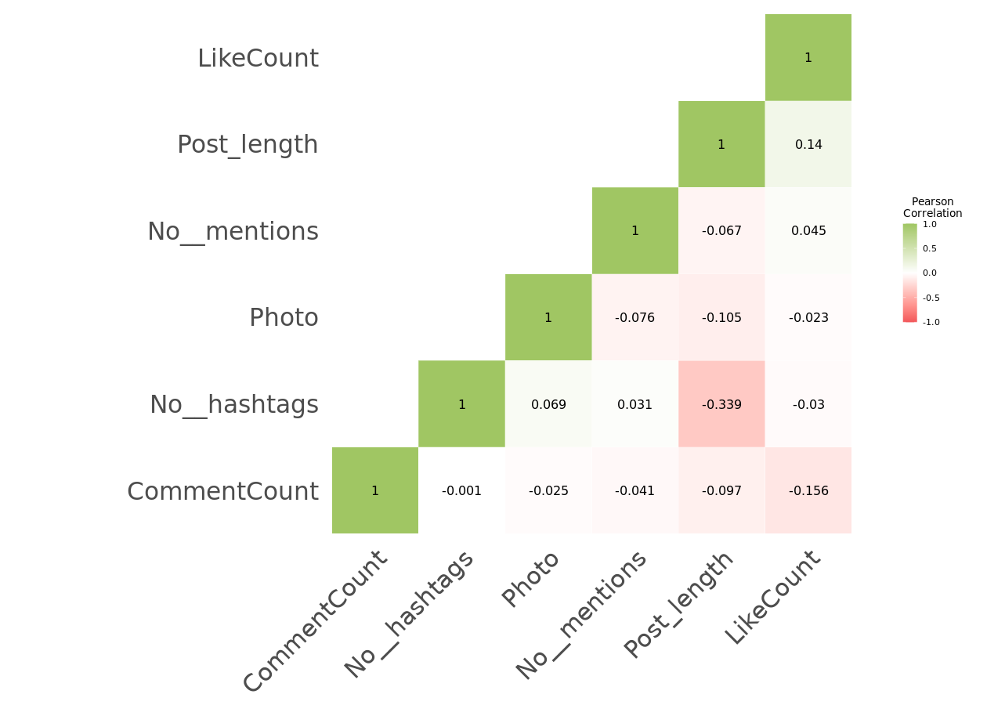

Question 3 Using just the data available in “Hashtags”, identify core themes that emerge from a semantic network analysis of the hashtags used by influencers and their followers. The Network Analysis tools within Enginius can be used to generate the semantic network (Select “Perform network clustering”).

Answer:

After executing network analysis of hashtags data, Network Clustering Segments are 11 (greedy) / 3 (hierarchical). Among which Spring is in the air has a hierarchical segment membership of one and Shoplocal, washbag, makeupbag, toiletrybag, linenbag, shopincornwall, gardencollection, linenhomewares, interiordesign are 1 (hierarchical)

Core themes identified:

Segment-Centric Hashtags: Hashtags corresponding to defined segments, expressing unique themes among communities.

Diverse Clusters: Greedy and hierarchical clustering offer distinct perspectives on topic grouping, providing more significant insights.

Recommendations:

Hashtags should be segmented to allow for focused engagement.

Exploring Various Themes: Understanding different hashtag clusters to develop a complete content strategy would be prominent.

Dynamic Campaigns: Using both hierarchical and greedy clustering findings to create adaptive and engaging campaigns.

This semantic network analysis reveals topic structures inside the influencer network, allowing Blue Apron to generate content and ads that appeal to certain communities and various subject clusters.

Network visualization for hashtags with all network metrics:

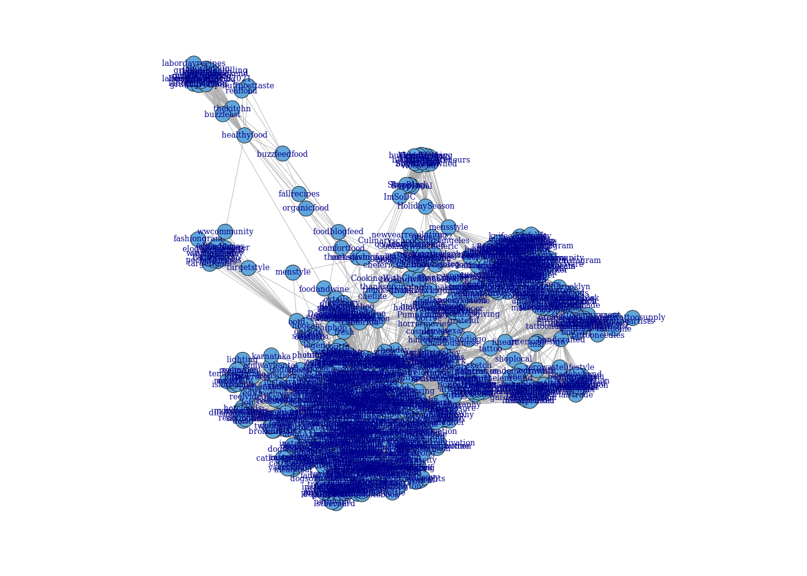

Question 4 Based on your answers to Questions 2 and 3, recommend content (topics and/or snippets from posts) that Blue Apron could use effectively in its own push-marketing initiatives (e.g., website, ads, blogs, traditional media).

Answer:

Based on the analysis of effective influencer posts and the semantic network of hashtags, Blue Apron can strategically build content for push-marketing activities across numerous channels like:

Featured Recipes: Using high-engagement influencer posts to highlight the ease of cooking with Blue Apron goods. Including visually engaging visuals and step-by-step directions.

User-Generated Content: Encouraging Blue Apron subscribers to share their culinary experiences using unique hashtags based on semantic network research. Using user-generated content in advertisements and on the website to foster a sense of community.

Seasonal Campaigns: Aligning push-marketing campaigns with seasonal themes discovered in hashtag clusters. For example, using the "Spring is in the Air" segment to promote fresh spring recipes and ingredients.

Influencer Collaborations: Collaborating with influencers that consistently create engaging content. Using samples from their posts in marketing materials to increase audience engagement and credibility.

Behind the Scenes Insights: Sharing behind-the-scenes looks at Blue Apron's operations, highlighting freshness, quality, and the journey of products from source to subscriber's kitchens.

Exclusive Promotions: Creating customized promos or discounts for specific hashtags or influencer collaborations to increase engagement and conversions.

By incorporating these content recommendations, Blue Apron can more effectively communicate its brand message, connect with its audience on a deeper level, and promote consumer engagement and conversion via push-marketing channels.

Question 5 Develop a strategy brief (summary in a paragraph or two in outline format) for CEO Linda Findley for her to use in a kick-off meeting to plan Blue Apron’s influencer marketing program going forward. In the strategy brief, articulate the goals, criteria, and metrics for success for the program based on your understanding of the business context of meal kit subscription services and your analyses of the influencer data available to you.

Answer:

Influencer Marketing Strategy Brief for CEO Linda Findley

Strategic Vision:

Objective: To improve Blue Apron's brand positioning and market share by implementing an innovative influencer marketing program that complements the company's objective of promoting culinary excellence at home.

Key goals:

Brand Recognition: Using influencers to promote Blue Apron's brand identity, emphasizing its commitment to culinary diversity, high-quality products, and sustainability.

Audience Connection: Creating true connections with the target audience by choosing influencers whose content authentically reflects Blue Apron's beliefs.

Conversion Optimization: Increasing conversions and subscriber growth by creating captivating narratives about the Blue Apron experience and translating influencer reach into meaningful business outcomes.

Influencer Selection Criteria:

Engagement Metrics: Prioritizing influencers that have a track record of driving robust engagement and sparking meaningful debates about content.

Brand Synergy: Partnering Blue Apron with influencers whose personal brands are in sync with the essence of the meal kit experience, ensuring organic integration.

Audience Metrics: Selecting influencers whose audience demographics match Blue Apron's target market, assuring resonance with potential customers.

Content Consistency: Looking for influencers who consistently provide high-quality material, indicating an unshakable dedication to authenticity and excellence.

Influencer Expertise: Using influencers with a track record of successful brand collaborations to capitalize on their knowledge of navigating promotional landscapes.

Performance metrics for success:

Engagement Rate: Tracking an orchestrated increase in engagement metrics such as likes, comments, and overall involvement with influencer material.

Subscriber Growth: Evaluating the growth effect of influencer marketing on subscriber acquisition, retention, and brand loyalty.

Sales Conversion: Measuring the rate of success by examining the relationship between influencer promotions and increase in Blue Apron meal kit sales.

Sentimental Harmony: Using sentiment analysis methods, assessing audience sentiment through comments and discussions on social media platforms to ensure a favorable and compelling brand image.

Hashtag Performance: Evaluating the effect of branded hashtags for arranging user-generated content and promoting a positive community vibe.

Implementation Plan:

Influencer Onboarding: Conducting a rigorous selection and onboarding process to establish criteria and goals of Blue Apron.

Content Collaboration: Collaborating with influencers to create a fascinating content composition that integrates Blue Apron items into their stories.

Promotional Campaigns: Creating exclusive promos and discounts to drive consumer interest and conversions.

Monitoring and Optimization: Beginning a watchful monitoring by examining performance data and fine-tuning techniques for peak performance.

Community Engagement: Encouraging a symphony of user-generated content and community involvement to create a harmonious relationship between Blue Apron, influencers, and the target audience.

This thorough and inventive influencer marketing plan intends to not only increase Blue Apron's brand visibility, but also to orchestrate a symphony of engagement, conversion, and community development in the competitive field of meal kit subscription services.